

**Effort: 20 mins**

Objective

In this lab, you will learn:

1. Import the notebook in Watson Studio

IBM Watson Setup

*If you have not created a Watson service before proceed with Step 1, otherwise go to Step 2:*

Step 1: For New Users (with no Watson service):

For this project, you will use your IBM Watson Studio account from the previous chapter.

Go to the IBM Cloud Watson Studio page:

[Click here](https://cloud.ibm.com/login?cm_mmc=Email_Newsletter-_-Developer_Ed%2BTech-_-WW_WW-_-SkillsNetwork-Courses-IBMDeveloperSkillsNetwork-PY0101EN-SkillsNetwork-19487395&cm_mmca1=000026UJ&cm_mmca2=10006555&cm_mmca3=M12345678&cvosrc=email.Newsletter.M12345678&cvo_campaign=000026UJ" \t "_blank)

You will see the screen in the figure below. Click the icon in the red box:

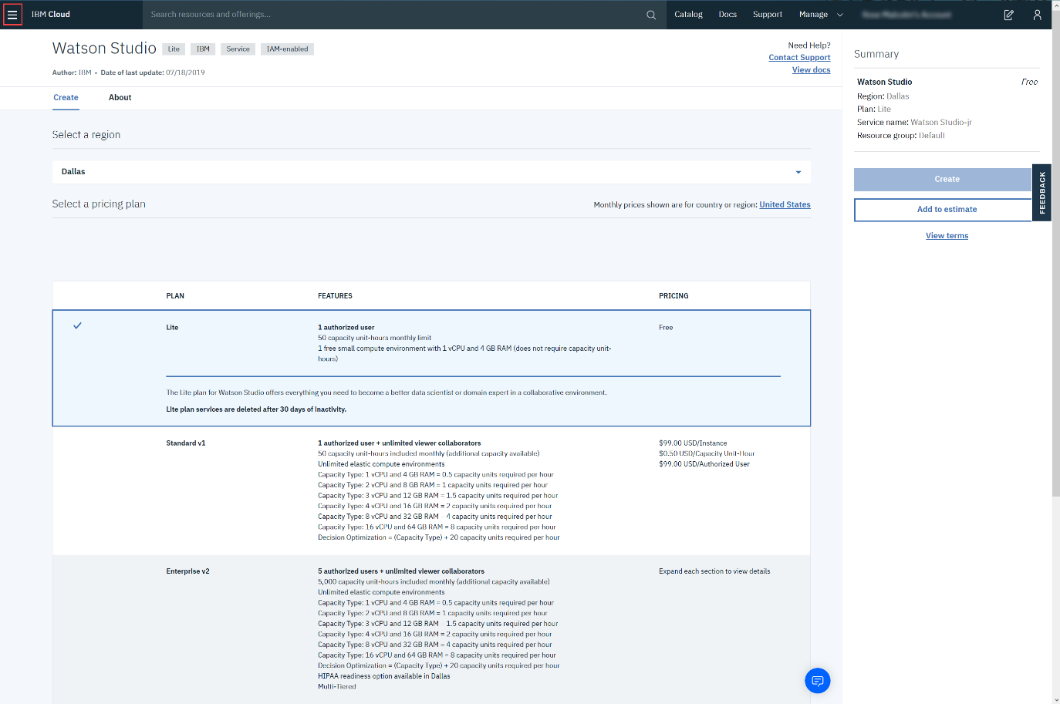

Then click **Watson**, as shown below:

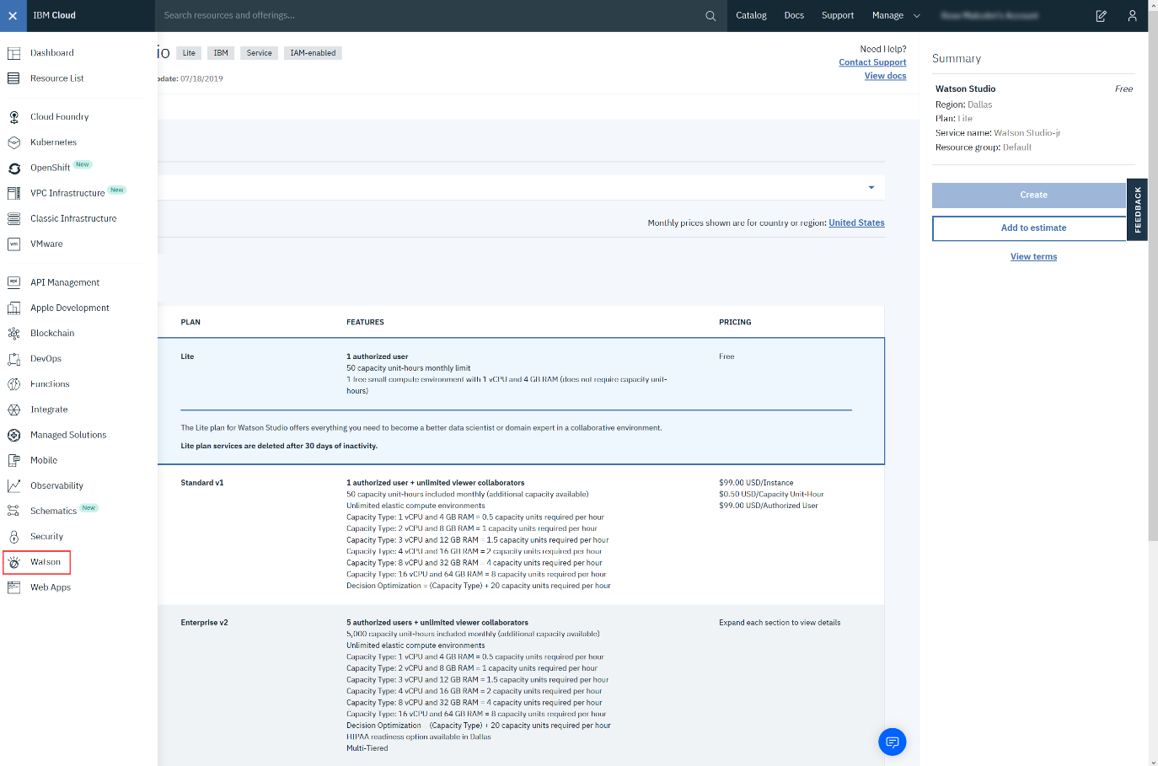

Then click **Browse Services.**

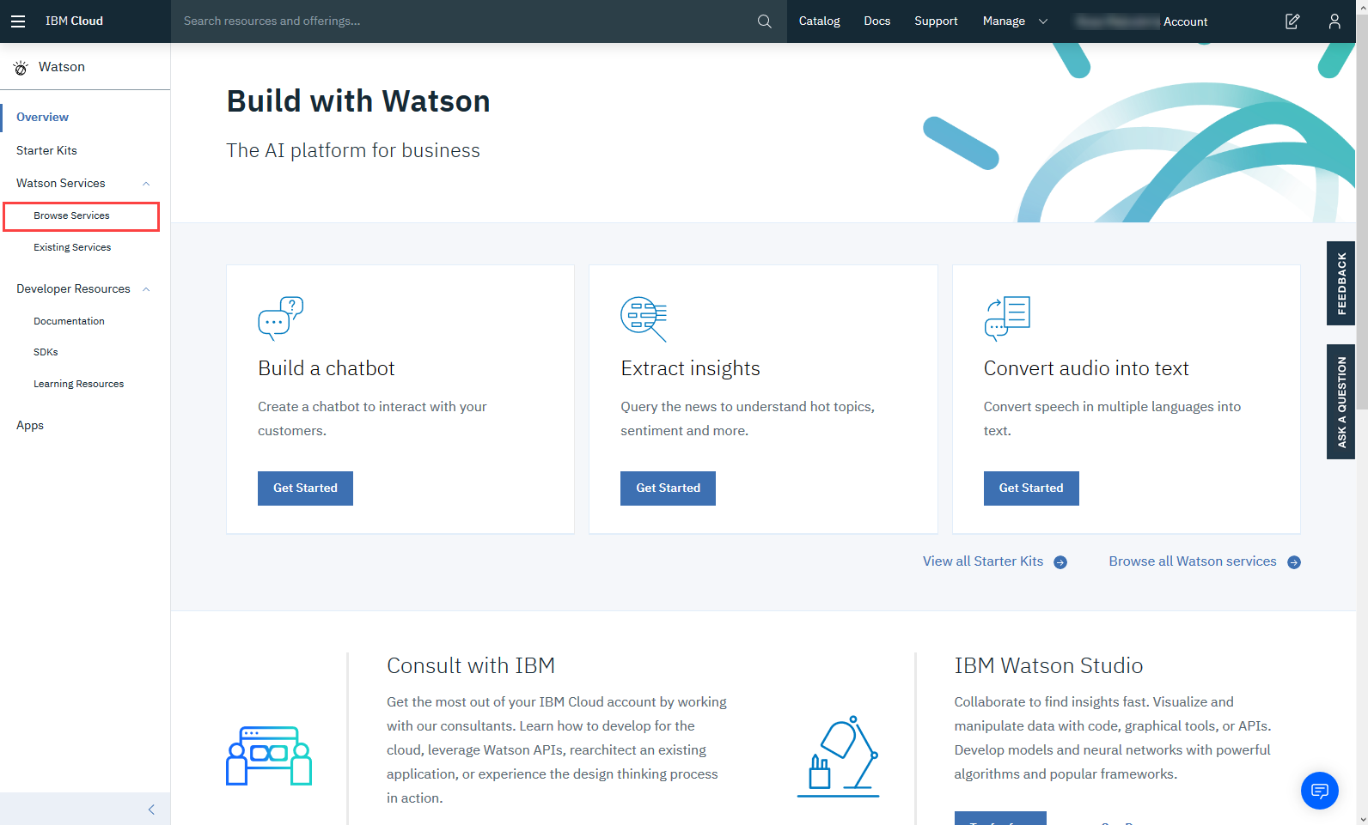

Scroll down and select **Watson Studio - Lite.**

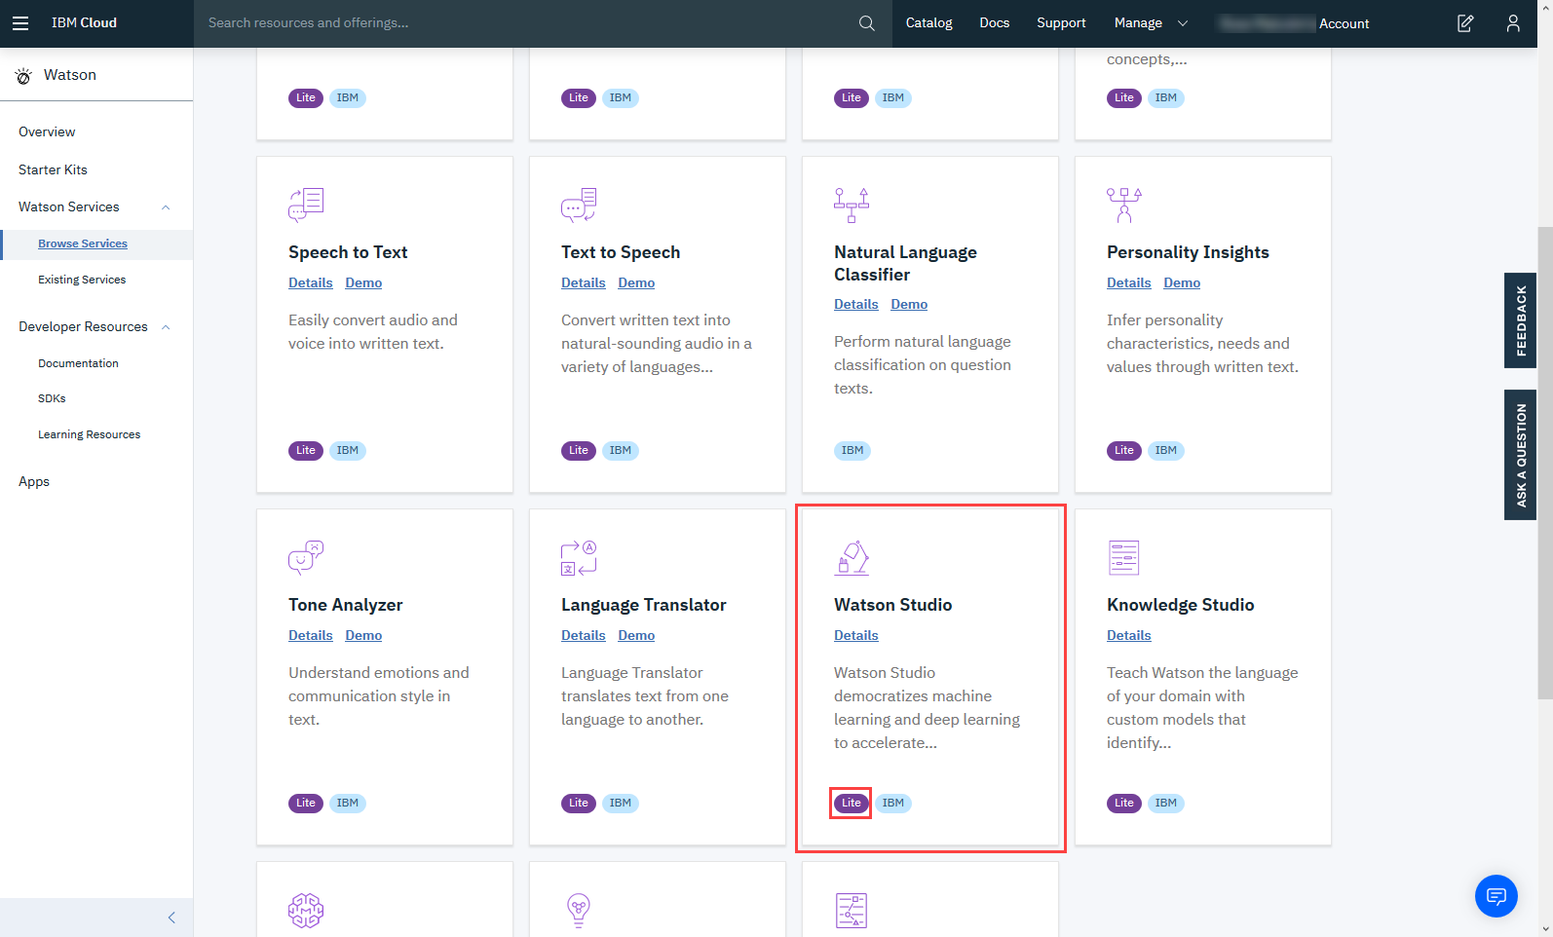

To create a Watson service using the Lite plan, click **Create.**

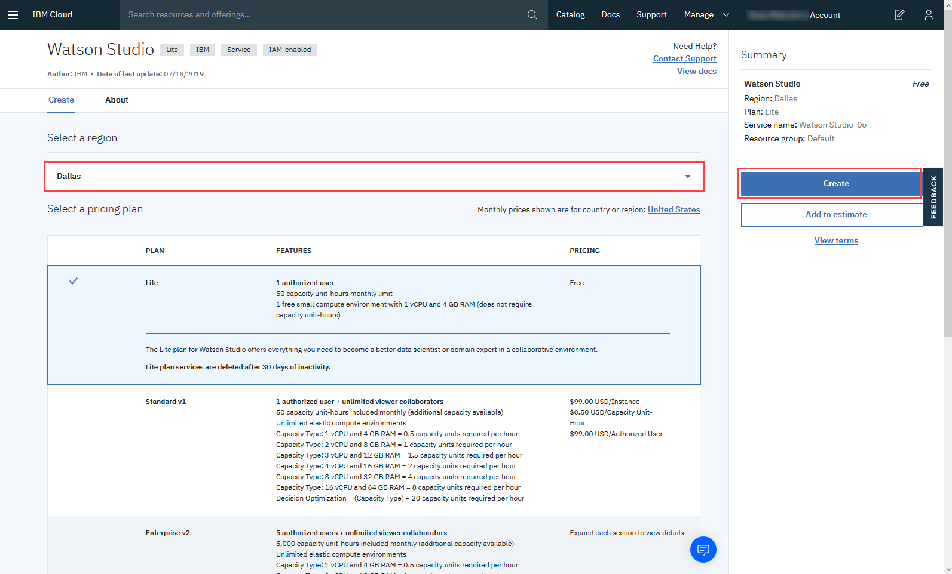

Now click **Get Started.**

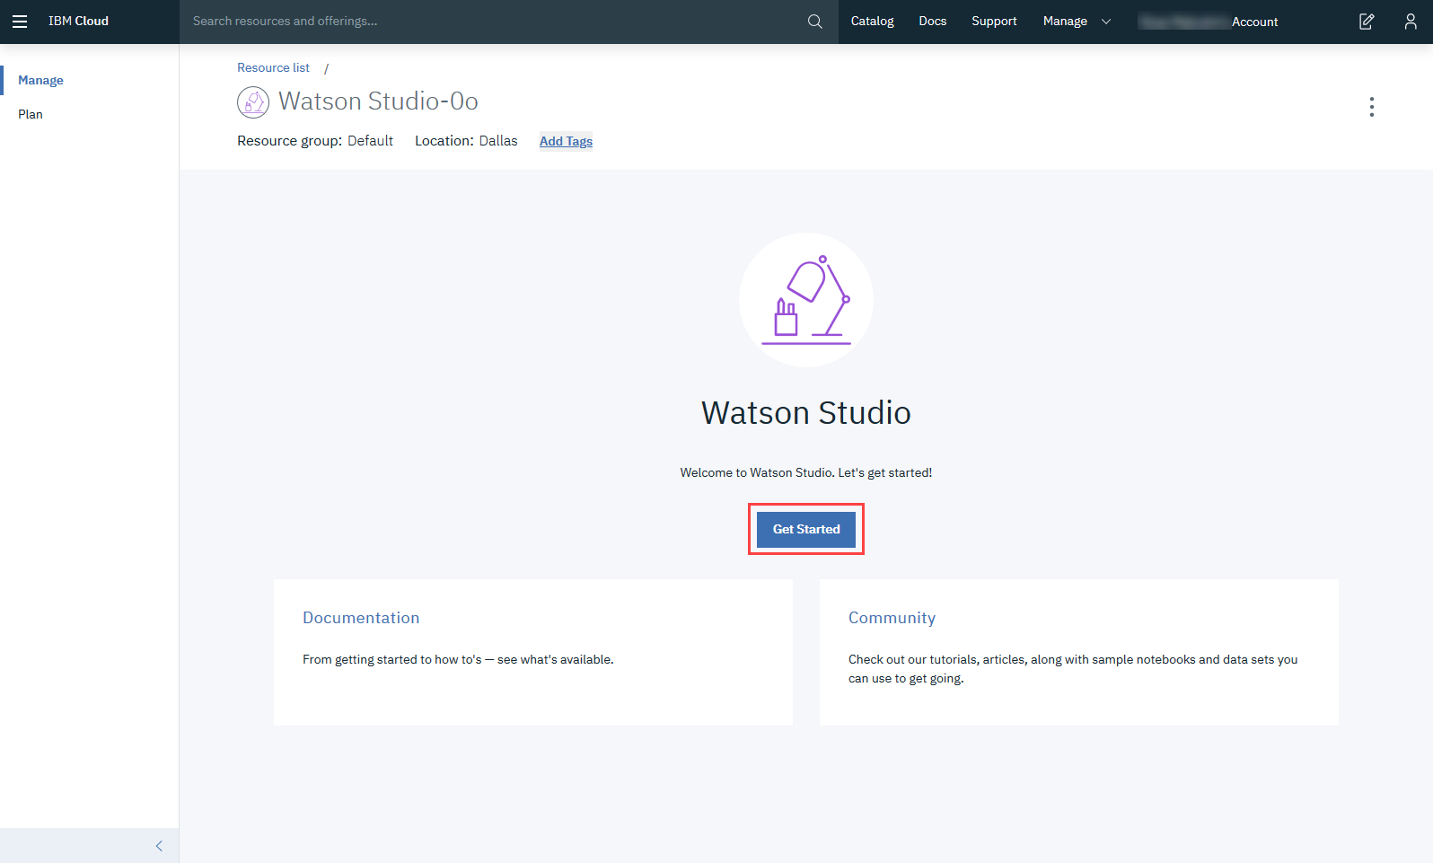

After creating the service continue with **Step 2.**

Step 2: For Existing Users (who already have Watson Service):

Go to the IBM Cloud Dashboard and click **Services.**

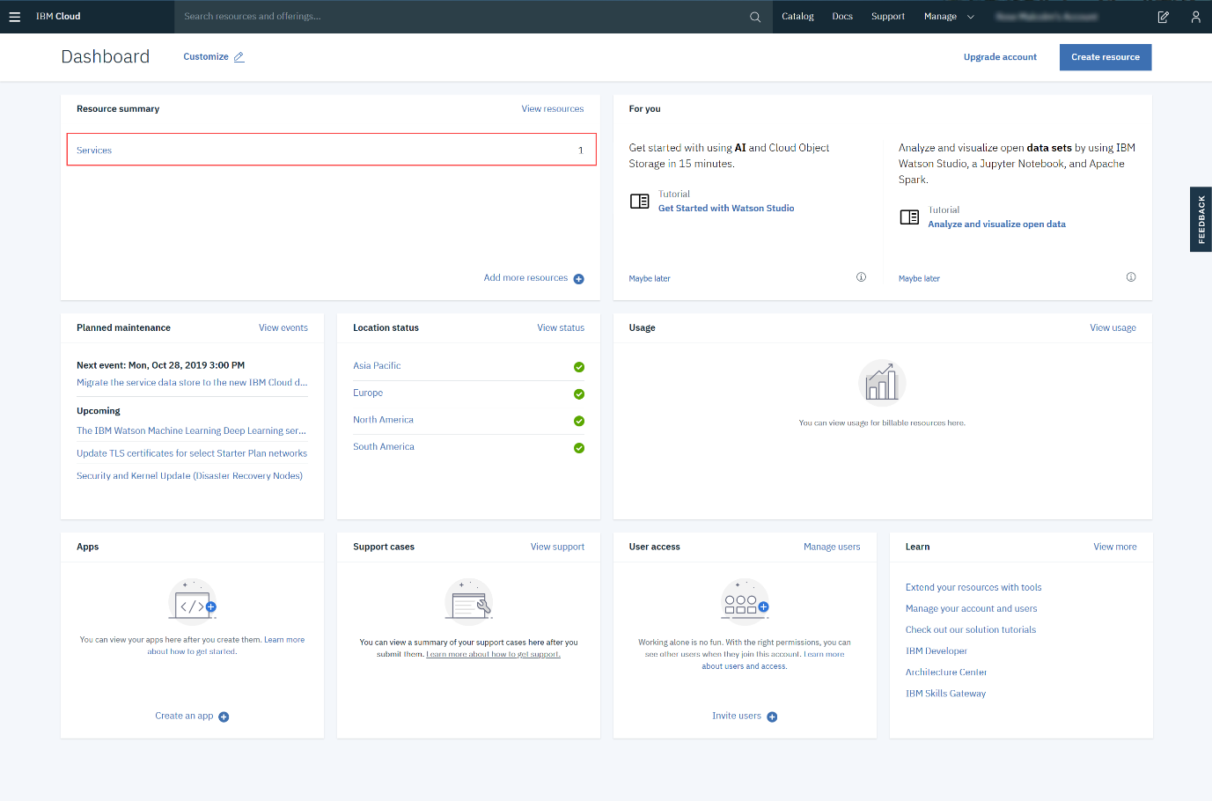

When you click on Services, all your existing services will be shown in the list. Click the **Watson Studio** service you created:

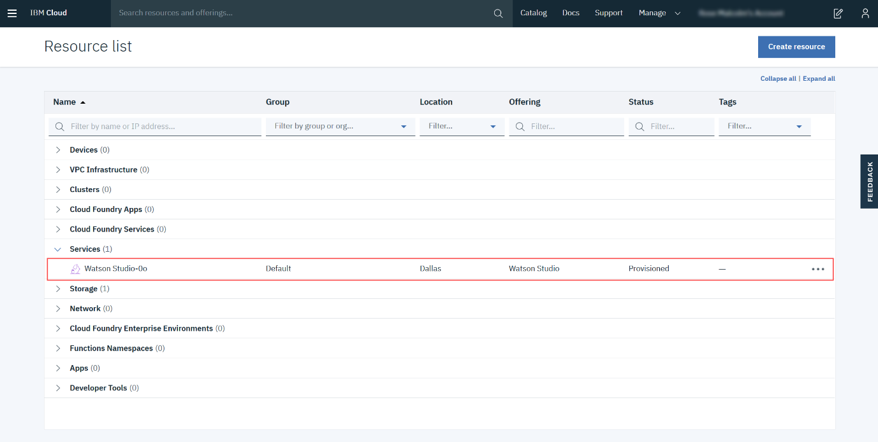

Then click **Get Started.**



**Step 3: Creating a Project**

Now you have to Create a project.

Click on **Create a project:**

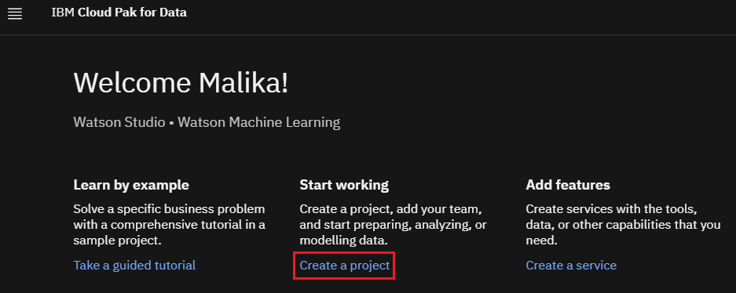

On the Create a project page, click **Create an empty project**

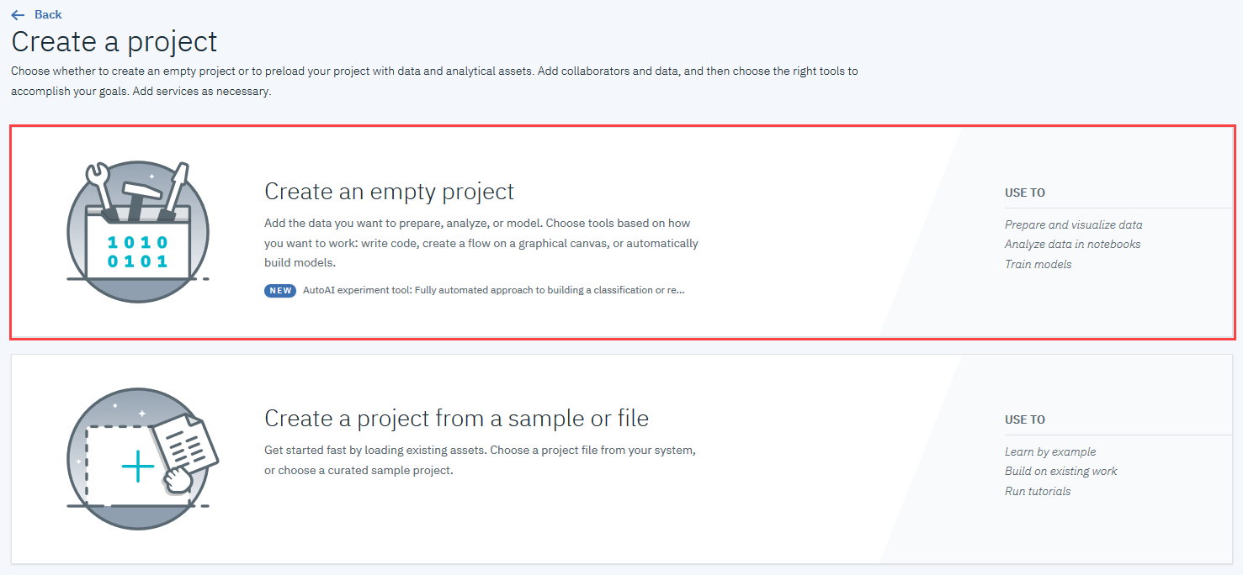

Provide a **Project Name** and **Description**, as shown below:

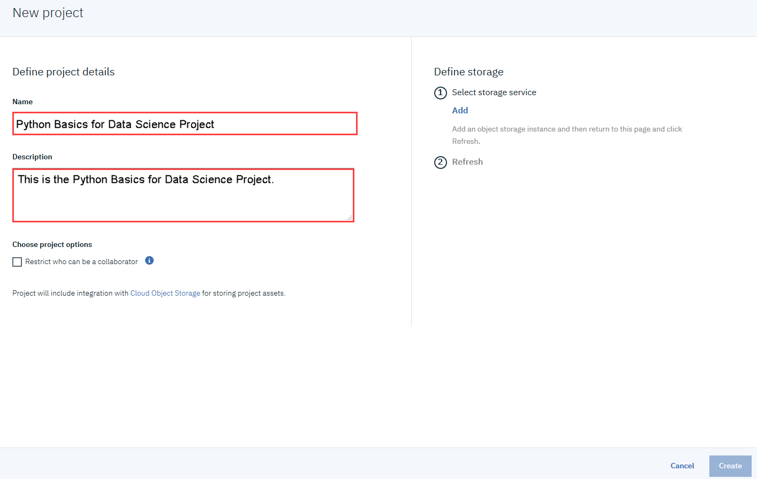

You must also create storage for the project.

Click **Add**

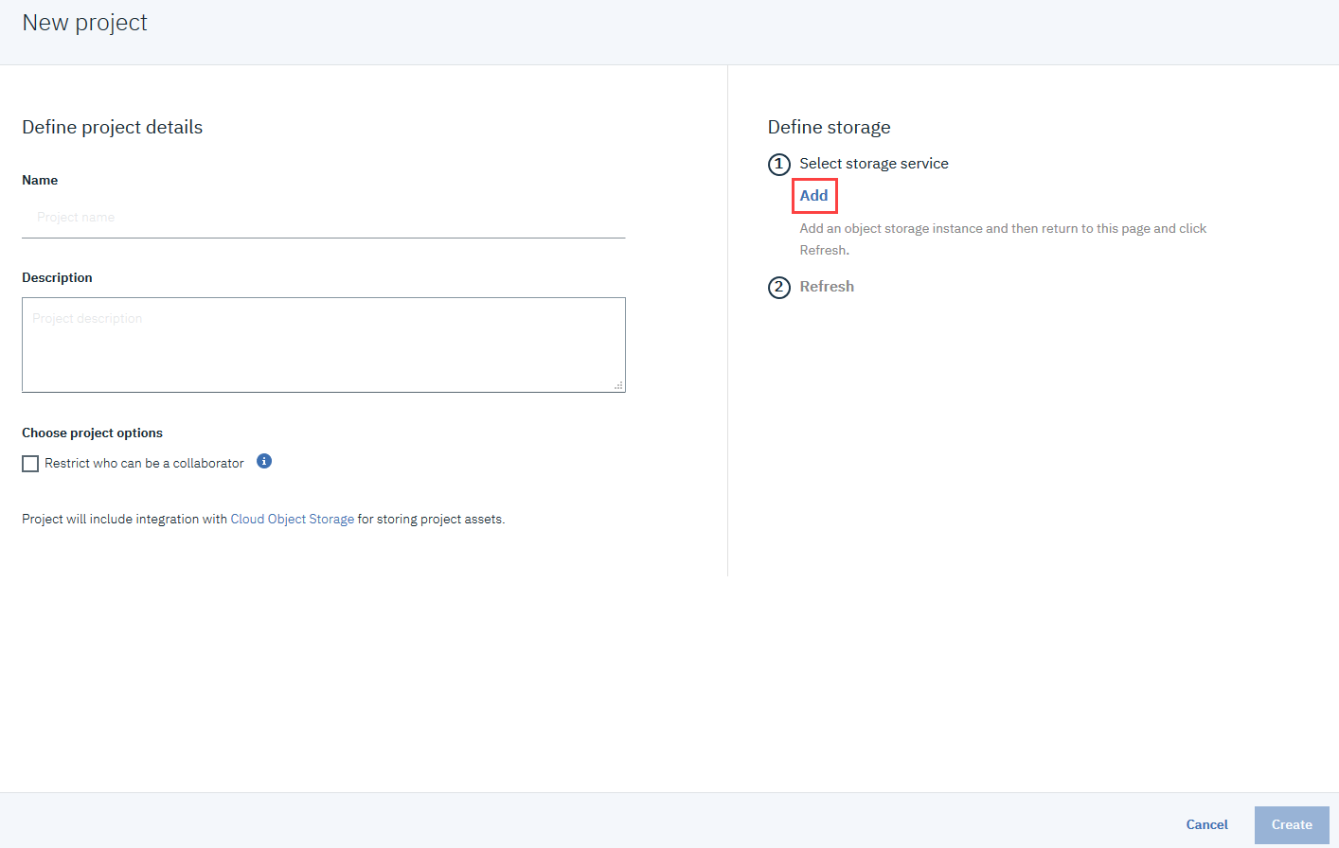

On the Cloud Object Storage page, scroll down and then click **Create.**

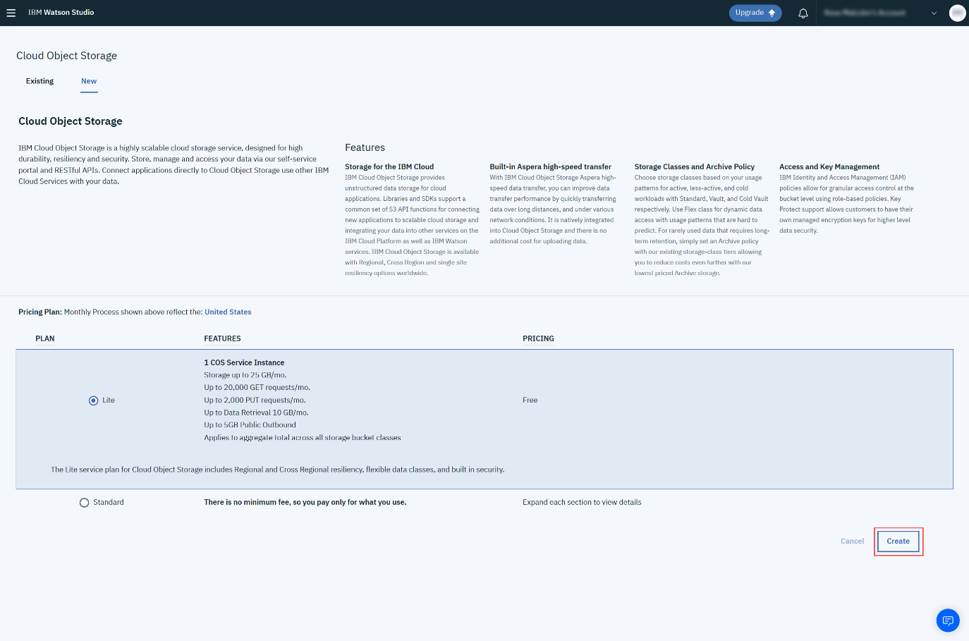

In the Confirm Creation box, click **Confirm.**

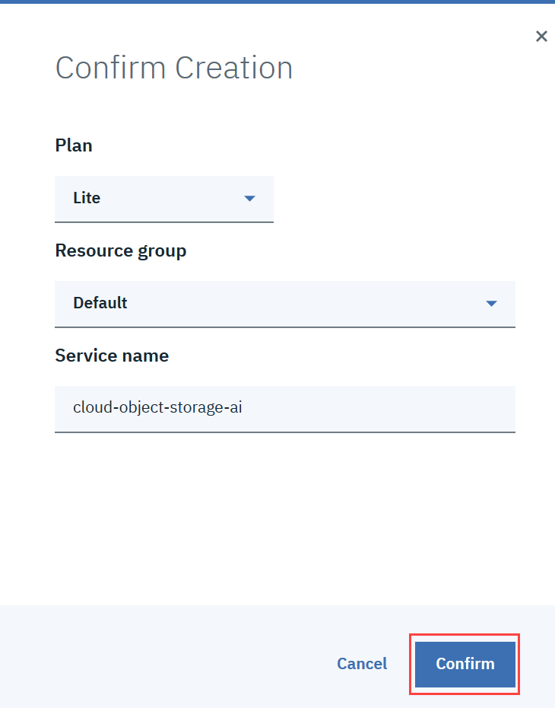

On the New project page, note that the storage has been added, and then click **Create.**

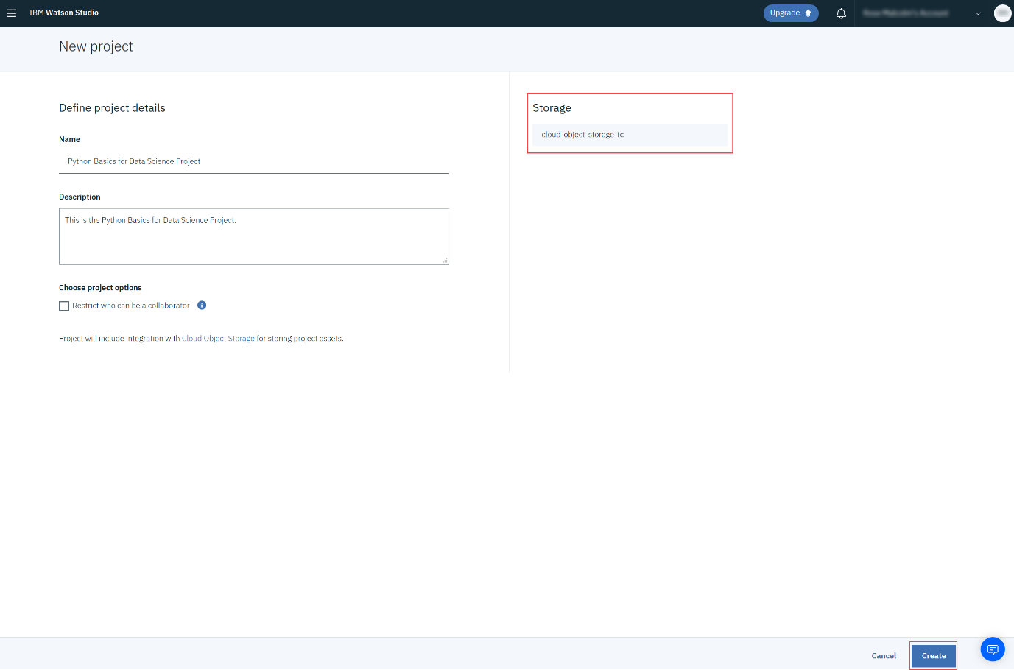

After creating the project you will need to add a Jupyter notebook to your project. Instructions for this are provided in a subsequent lab.